**Problem Statement 1:** Write a Program to find whether the Number is Palindrome or Not.

**Algorithm:**

Step 1:start

Step 2: read a number num

Step 3: set reverse=0,temp=num

Step 4: while num>0 true continue else go to step 8

Step 5:set rem=num%10

Step 6: set reverse=reverse*10+rem

Step 7:set num=num/10 go to step 4

Step 8: compare temp==reverse if true print ‘Palindrome’ else print ‘Not Palindrome’

Step 9: stop

**Flow Chart:**

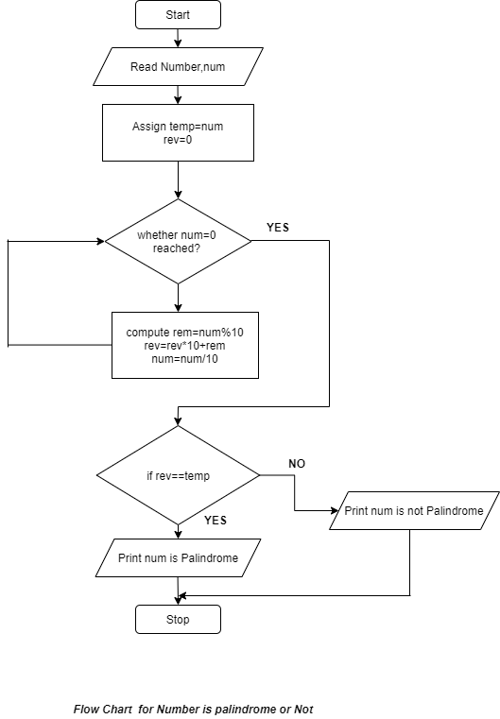

**Code:**

**package** com.zensar.javaassignment;

**public** **class** PalindromeNumber {

**private** **int** number;

**public** **int** getNumber() {

**return** number;

}

**public** **void** setNumber(**int** number) {

**this**.number = number;

}

**public** **void** checkPalindrome() {

**int** temp=number;

**int** digit=0;

**int** rev=0;

**while**(number>0) {

digit=number%10;

rev=(rev*10)+digit;

number=number/10;

}

**if**(rev==temp) {

System.***out***.println("The Number is Palindrome.....");

}**else** {

System.***out***.println("The Number is not Palindrome.....");

}

}

**public** **static** **void** main(String[] args) {

PalindromeNumber pn=**new** PalindromeNumber();

pn.setNumber(454);

pn.checkPalindrome();

}

}

**Output:**

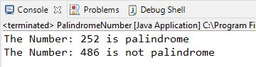

**Problem Statement 2:** Write a Program to find given number is Armstrong number or not.

**Algorithm:**

Step 1:start

Step 2: read a number num

Step 3: set sum=0,temp=num

Step 4: while num>0 true continue else go to step 8

Step 5:set rem=num%10

Step 6: set sum=sum+(rem*rem*rem)

Step 7:set num=num/10 go to step 4

Step 8: compare sum==temp if true print ‘Armstrong Number’ else print ‘Not Armstrong Number’’

Step 9: stop

**Flowchart:**

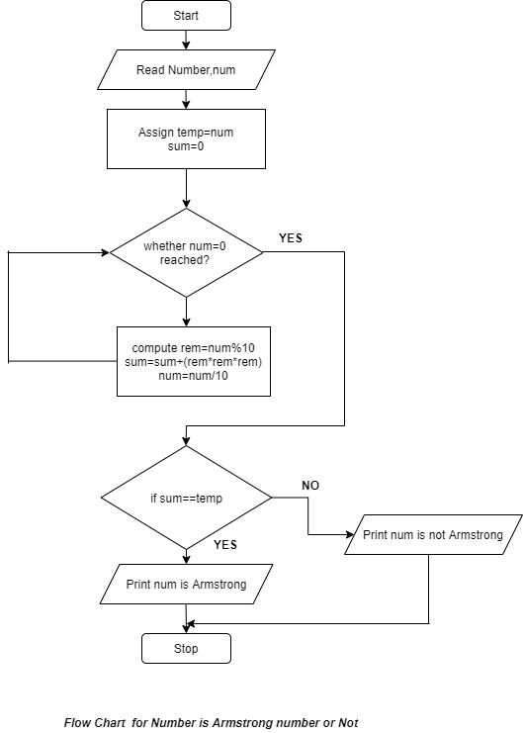

**Code:**

**package** com.zensar.javaassignment;

**public** **class** ArmstrongNumber {

**private** **int** number;

**public** **int** getNumber() {

**return** number;

}

**public** **void** setNumber(**int** number) {

**this**.number = number;

}

**public** **void** checkArmstrong() {

**int** temp = number;

**int** digit = 0;

**int** sum = 0;

**while** (number > 0) {

digit = number % 10;

number = number / 10;

sum = sum + (digit * digit * digit);

}

**if** (sum == temp) {

System.***out***.println("The number is Armstrong Number.....");

} **else** {

System.***out***.println("The number is not Armstrong Number.....");

}

}

**public** **static** **void** main(String[] args) {

ArmstrongNumber an = **new** ArmstrongNumber();

an.setNumber(355);

System.***out***.println("Number: " + an.getNumber());

an.checkArmstrong();

}

}

**Output:**

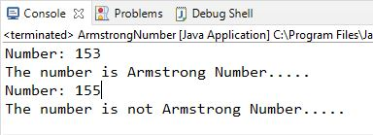

**Problem Statement 3:** Write a Program to print Fibonacci Series.

**Algorithm:**

Step 1: start

Step 2: initialize numbers num1=0,num2=1 and declare num3

Step 3: set count

Step 4: print num1 and num2

Step 5: for i=2 upto i<count continue else go to step 9

Step 6: num3=num1+num2

Step 7: print num3

Step 8: num1=num2 and num2=num3

Step 9: i=i+1 and go to step 5

Step 9: stop

**Flowchart:**

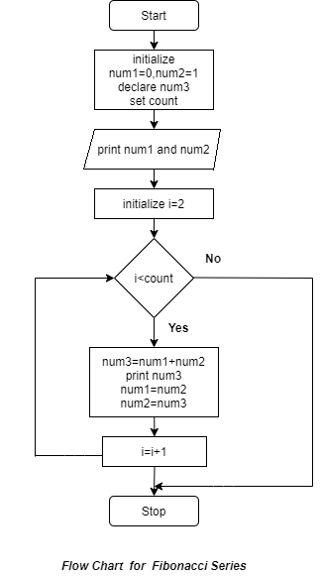

**Code:**

**package** com.zensar.javaassignment;

**public** **class** FibonacciSeries {

**private** **int** number;

**public** **int** getNumber() {

**return** number;

}

**public** **void** setNumber(**int** number) {

**this**.number = number;

}

**public** **void** generateFibonacci() {

**int** num1 = 0;

**int** num2 = 1;

**int** num3;

System.***out***.print(num1 + " " + num2);

**for** (**int** i = 2; i < number; i++) {

num3 = num1 + num2;

System.***out***.print(" " + num3);

num1 = num2;

num2 = num3;

}

}

**public** **static** **void** main(String[] args) {

FibonacciSeries fs = **new** FibonacciSeries();

fs.setNumber(10);

System.***out***.print("Fibonacci Series :- ");

fs.generateFibonacci();

}

}

**Output:**

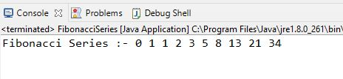

**Problem Statement 4:** Write a Program to convert a number from Decimal to binary and binary to Decimal.

**Algorithm :: 1.Decimal to Binary**

Step 1: start

Step 2: read a number num

Step 3: set i=0,declare array binArr[]

Step 4: while num>0 true continue else go to step 8

Step 5: set binArr[i]=num%2

Step 6: set num=num/2

Step 7:set i=i+1

Step 8: print binArr[] in reverse order

Step 9: stop

**Algorithm :: 2. Binary to Decimal**

Step 1: start

Step 2: read a number binNum

Step 3: set cnt=0,decimal=0

Step 4: while num>0 true continue else go to step 9

Step 5: set temp=num%10

Step 6: set decimal=decimal+temp*pow(2,cnt)

Step 7: set binNum=binNum/10

Step 8: set cnt=cnt+1

Step 9: print decimal number

Step 9: stop

**Flowchart 1: Decimal to Binary**

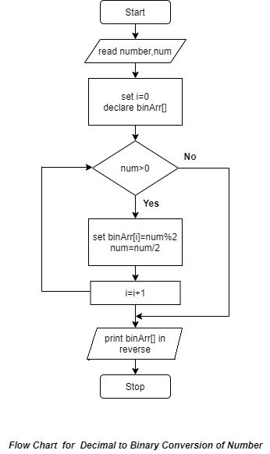

**Flowchart 2: Binary to Decimal**

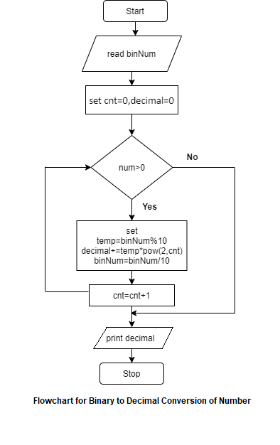

**Code:**

**package** com.zensar.javaassignment;

**public** **class** ConvertNumber {

**public** **void** decToBinary(**int** num) {

**int**[] binNumber=**new** **int**[40];

**int** i=0;

**while**(num>0) {

binNumber[i]=num%2;

num=num/2;

i++;

}

**for**(**int** j=i-1;j>=0;j--) {

System.***out***.print(binNumber[j]);

}

}

**public** **void** binToDecimal(**int** binNum) {

**int** cnt=0;

**int** decimal=0;

**while**(binNum>0) {

**int** temp=binNum%10;

decimal+=temp*Math.*pow*(2, cnt);

binNum=binNum/10;

cnt++;

}

System.***out***.println(decimal);

}

**public** **static** **void** main(String[] args) {

ConvertNumber cn=**new** ConvertNumber();

System.***out***.print("Binary Representation: ");

cn.decToBinary(6);

System.***out***.println();

System.***out***.print("Decimal Representation: ");

cn.binToDecimal(110);

}

}

**Output:**

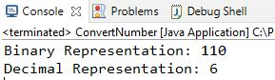

**Problem Statement 5:** Write a Program to swap two numbers without using third variable.

**Algorithm:**

Step 1: start

Step 2: read two numbers num1 and num2

Step 3: set num1=num1+num2

Step 4: set num2=num1-num2

Step 5: set num1=num1-num2

Step 6: print swapped numbers

Step 7: stop

**Flowchart:**

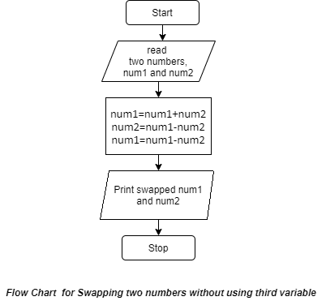

**Code:**

**package** com.zensar.javaassignment;

**public** **class** SwapNumbers {

**public** **static** **void** main(String[] args) {

**int** num1 = 10;

**int** num2 = 20;

System.***out***.println("Swapping two Number without using third variable...");

System.***out***.println("Before Swapping: ");

System.***out***.println("Number1:" + num1 + " Number2:" + num2);

num1 = num1 + num2;

num2 = num1 - num2;

num1 = num1 - num2;

System.***out***.println("After Swapping: ");

System.***out***.println("Number1:" + num1 + " Number2:" + num2);

}

}

**Output:**

